**2.1 Existing systems**

**1.Fake news Detector**

There exists a large body of research on the topic of machine learning methods for deception detection, most of it has been focusing on classifying online reviews and publicly available social media posts. Particularly since late 2016 during the American Presidential election, the question of determining 'fake news' has also been the subject of particular attention within the literature.

Conroy, Rubin, and Chen outline several approaches that seem promising towards the aim of perfectly classifying the misleading articles. They note that simple content-related n-grams and shallow parts-of-speech (POS) tagging have proven insufficient for the classification task, often failing to account for important context information. Rather, these methods have been shown useful only in tandem with more complex methods of analysis. Deep Syntax analysis using Probabilistic Context Free Grammars (PCFG) have been shown to be particularly valuable in combination with n-gram methods. Feng, Banerjee, and Choi are able to achieve 85%-91% accuracy in deception related classification tasks using online review corpora.

Feng and Hirst implemented a semantic analysis looking at 'object:descriptor' pairs for contradictions with the text on top of Feng's initial deep syntax model for additional improvement. Rubin, Lukoianova and Tatiana analyze rhetorical structure using a vector space model with similar success. Ciampaglia et al. employ language pattern similarity networks requiring a pre-existing knowledge base.

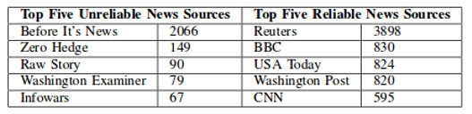

**2.Sentiment Detector**

The solution is discussed in the article by Mudinas et al. [MZL12]: a concept-level sentiment analysis system called pSenti which combines lexicon based and learning based approaches. It measures and reports the overall sentiment of a review through a score that can be positive, negative or neutral or 1–5 stars classification. The main advantages and main interests of this article are the lexicon/learning symbiosis, the detection and measurement of sentiments at the concept level and the lesser sensitivity to changes in topic domain.

It operates in four parts. First, the pre-processing of the review where the noise (idioms and emoticons) is removed and each word is tagged and stored by the method Part Of Speech (POS). Second, the aspects and views are extracted to generate a list of top 100 aspect groups and top 100 views. The aspects are identified as nouns and noun phrases, and the views as sentiment words, adjectives and known sentiment words which occur near an aspect. Then the lexicon-based approach is used to give a “sentiment value” to any sentiment word and generates features for the supervised machine learning algorithm. Finally, this algorithm generates a “feature vector” for each aspect which is either the sum of the sentiment value for a sentiment word or the number of occurrences of this word in relation with other adjectives.

To evaluate this method, experiments were conducted on two datasets: software reviews (more than 10,000) and movie reviews (7,000). Software reviews were separated into two categories: software editor reviews and customer software reviews. As a result, pSenti’s accuracy was proved close to the pure learning-based system and higher than the pure lexicon-based method. It was also shown that the performance was not as good on customer software reviews as on software editor reviews because customer software reviews are usually much “noisier” (with comments that are irrelevant for the subject) than professional software editor reviews. Its accuracy was also affected by a large number of reviews for which it failed to detect any sentiment or assigned neutral score. However, the A Study and Comparison of Sentiment Analysis Methods for Reputation Evaluation sentiment separability in movie reviews was much lower than in software reviews. One of the reasons is that many movie reviews contain plot description and many quotes from the movie where words are identified as sentiments by the system.

**3.Spam Detector**

Various techniques have been explored to relieve the problem of email spams. Used, previous works on spam detection can be generally classified based on features of e-mails. It can be classified into three categories:

1) content-based methods,

2) non content based methods, and

3) others. Initially, researchers model this problem as a binary text classification task by analyzing email content text.

To relieve the spam problem various techniques have been explored. Spam detection can be classified in previous works based on the characters of email.

Naive Bayes and Support Vector Machines are the representatives of this category. Generally Naive Bayes methods train a probability model using classified emails, and each word in emails will be given a probability of being a suspicious spam keyword. As for SVMs, it is a supervised learning method that has outstanding performance on text classification tasks.

Traditional SVMs and improved SVMs have been investigated. The excellent results with static data sets are reported by the conventional machine learning techniques. But it has some disadvantage that it is cost-prohibitive for large-scale applications Thus the latest information to adapt to the rapid evolving nature of spams. The spam detection of these methods on the email corpus with various languages has been less studied yet. Many other classifications are also account for spam detection. They are markov random field model, neural network and logic regression, and certain specific features, such as URLs and images

**4.Summarizer**

Shah et al says Automatic text summarization of Wikipedia articles is difficult to detect subtopic in documents. There are two new approaches for summarizing the text. The first method is to adjust the frequency of the words based on the root form of the word, and also the frequency of its synonyms present in the text. The second method is to identify sentences containing citations or references and give them a higher weight. The advantage of this approach is effective sentence ranking in summary. The disadvantage of this approach is use of citations with higher weight to sentence so unimportant information is added in summary.

Jain et al says The limitation of the approach is dealing with problems of information redundancy, sentence ordering and fluency. Graph and Cluster Based approaches in Multi Document summarization and gives the idea to improve summary in less effort or even to construct new or hybrid procedure for next generation. The advantage of this approach is to generate smooth summaries as compared to ranking algorithms. The disadvantage of this approach is information loss during summarization.

Atefeh Ferdosipour says The effectiveness of sentence scoring method depends upon length of document and the type of language used in document. Cohesion approach is grammatical and lexical linking within a text or sentence that holds a text together and gives it meaning for increasing effectiveness of summary. Cohesion devices that create coherence in text are as Reference, Substitution, Elipse, Lexical cohesion and Conjunction. Grammatical Cohesion is referring to structural content. Lexical Cohesion is referring to the language content of a piece. The advantage of this approach is to use a hybrid approach. The disadvantage of this approach is varies the document length

**2.2 Proposed Solution**

* We create a Web-based application where the user can give the article that had been received by them and as an output the user can know whether the article is valid or not, or detecting sentiment of the news, or can check whether the article is spam or not, and at last summarizing the article. The Web based application will be using a machine learning model to carry out all above operations.
* For Fake news Detection we first create the article in the form of data frames the next part is applying TFIDF vectorization which will count the frequency of each word and then creating the accuracy matrix to predict the accuracy score, next step is applying Naive Bayes Classifier to predict news belong to which class, the last step is applying Passive Aggressive Classifier, Passive Aggressive algorithms in this model gives us a 93.33% accurate result. It is an online learning algorithm. Such an algorithm remains passive for a correct classification outcome, and turns aggressive in the event of a miscalculation, updating and adjusting. Unlike most other algorithms, it does not converge. Its purpose is to make updates that correct the loss, causing very little change in the norm of the weight vector.
* For Sentiment Analysis first we create a bag of words, it is a function in which a text (such as a sentence or a document) is represented as the bag (multiset) of its words, disregarding grammar and even word order but keeping multiplicity. The next part is applying TFIDF VECTORIZATION here the frequency of each word is counted and stored. The next part is word embedding. Word embedding is any of a set of language modeling and feature learning techniques in natural language processing (NLP) where words or phrases from the vocabulary are mapped to vectors of real numbers. Last part is applying Natural Language Processing to Extract the sentiment of the string.
* For Spam Classifier we first create the article in the form of data frames the next part is applying TFIDF vectorization which will count the frequency of each word and then creating the accuracy matrix to predict the accuracy score, next step is applying Naive Bayes Classifier to predict news belong to which class, Naive Bayes classifiers are a collection of classification algorithms based on Bayes' Theorem. It is not a single algorithm but a family of algorithms where all of them share a common principle, i.e. every pair of features being classified is independent of each other. The last is applying multinomial classification to predict whether the article is spam or not, the model gives the accuracy of 83-86%.
* For Summarizer we create a bag of words, it is a function in which a text (such as a sentence or a document) is represented as the bag (multiset) of its words, disregarding grammar and even word order but keeping multiplicity. The next step is applying the summarize function to get the summary of the article.

**2.3 Feasibility Study**

* It includes consideration of all possible ways to provide solution to a given problem.
* The proposed solution should satisfy all the user requirements and should be flexible enough so that future changes can be easily done based on future upcoming requirements

**Economical Feasibility:**

1.This is a very important aspect to be considered while developing a project, we decided the technology based on minimum cost factory.

2.All hardware and software cost has to be borne by the organization.

**Technical Feasibility:**

1.This includes study of function, performance and constrains that may affect the ability to achieve the acceptance system.

2.For this feasibility study, we studied complete functionality to be provided in system and check if everything as possible using different types of front-end and back-end

**Operational Feasibility:**

1.No doubt the proposed system is fully GUI based that is very user friendly and all inputs to be taken all self-explanatory.

2.Besides, a proper training has been conducted to let know the essence of the system to the user so that they can feel comfortable with the new systems.

3.As far as our study is concerned the clients are comfortable and happy as the system has cut down their loads and doing.

**4.2 Conceptual level class diagram**

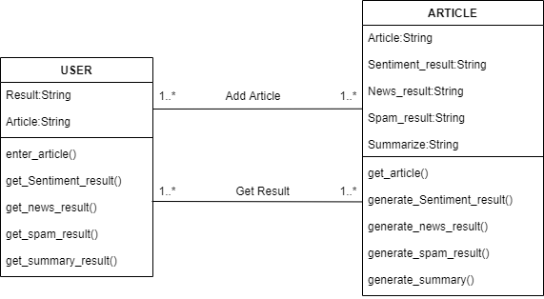.

**Description for conceptual class diagram**

1.Class user

There are following methods and attributes in class user

I Attributes-

a.Article-Contain the article to be validated, spam classified, summarized or sentiment identified

b.result-Stores any of the one result as only on result is generated at the time

II Methods-

a.enter_article() - Method allowing system to get article from user

b.get_sentiment_result() - Method allowing user to get result of sentiment analysis

c.get_news_result() - Method allowing user to get result of news analysis

e.get_spam_result() - Method allowing user to get result of spam analysis

f.get_summary_result() - Method allowing user to get result of summary of article

2 Article

I Attributes-

a.Article-Contain the article to be validated, spam classified, summarized or sentiment identified

b.Sentiment_result-String Containing sentiment analysis result.

c.News_result-String Containing Fake news result.

d.Spam_result-String Containing Spam analysis result

e.Summarize-String Containing Summary of Article

II Methods-

a.get_article() - Method allowing system to fetch article entered by user.

b.generate_sentiment_result() - Method allowing user to generate result using sentiment analysis

c.generate_news_result() - Method allowing user to generate result using Fake news analysis

e.generate_spam_result() - Method allowing user to generate result using spam analysis

f.generate_summary_result() - Method allowing user to generate summary of article

**4.3 Conceptual level activity diagram-**

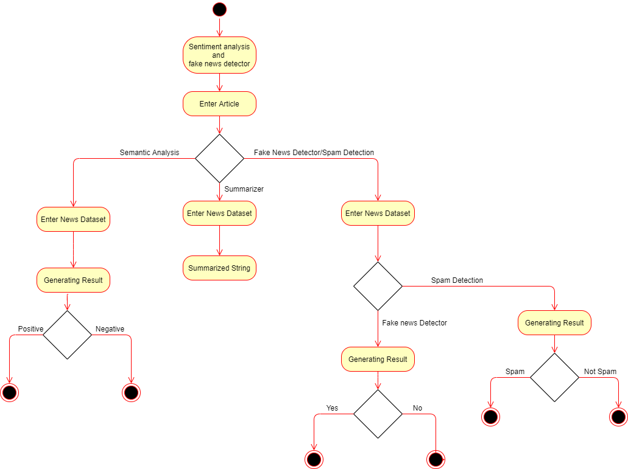

Description

1.The first activity is visiting the website.

2.The second activity is Enter Article Here users enter the news article.

3.In the third activity the user has to select the activity he wants to perform out of four activities listed as Sentiment Detection, Summarizer, Fake News Detector and Spam Detector.

4.If the User chooses the activity Sentiment Detection Then following are the next activities performed-

4.1.First activity is converting the article into the form of a dataset.

4.2.The fifth activity is generating results out of the analysis.

4.3.If last step is positive means that sentiment is positive else sentiment is negative.

5.If the user chooses the activity summarizer the following activities are performed-

5.1.First activity is converting the article into the form of a dataset.

5.2.The last activity is generating the summary out of analysis.

6.If the person chooses activities Fake news detector or Spam detector following are the common activities involved in both-

6.1.The first activity in both activities is converting the article in the form of a dataframe that is a dataset.

6.2.If the person has chosen Fake new detector here are some other activities involved-

6.2.1.The next activity is generating the result from the analysis, if the condition is yes it means the news is true, else if condition is no it means the news is fake.

6.3.If the person have chosen Spam Detector here are some other activities involved-

6.3.1.The next activity is generating the result from the analysis, if the condition is yes it means the article is Spam, else if condition is no it means the article is not Spam.

**4.5 Database Design ER diagram**

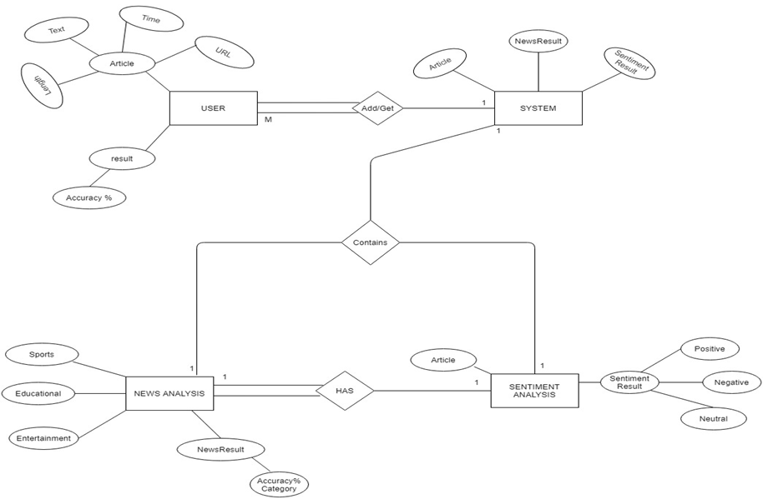

**Description-**

1.The first entity is User which contains the attributes result and article

2.The Result attributes contain Sub attribute accuracy percentage

3.The Article attribute contains Sub attributes such as URL, language, text and time.

4.The relation between User and System is one to many. As there can be many users at one time

5.The System Contains the entities News Analysis and Sentiment analysis

6.The News analysis entity contains attributes sports, educational, entertainment and news results which contain the attribute accuracy percentage.

7.The sentiment analysis contain attributes article and sentiment result

8.The sentiment result contains the attribute positive, negative and neutral.

9.The relation between News analysis and Sentiment analysis is that News analysis has Sentiment analysis

10.There is one to one connectivity between news analysis and Sentiment analysis.

11.News analysis has total participation whereas the Sentiment analysis has partial participation

**5.1** **Detailed class diagram**

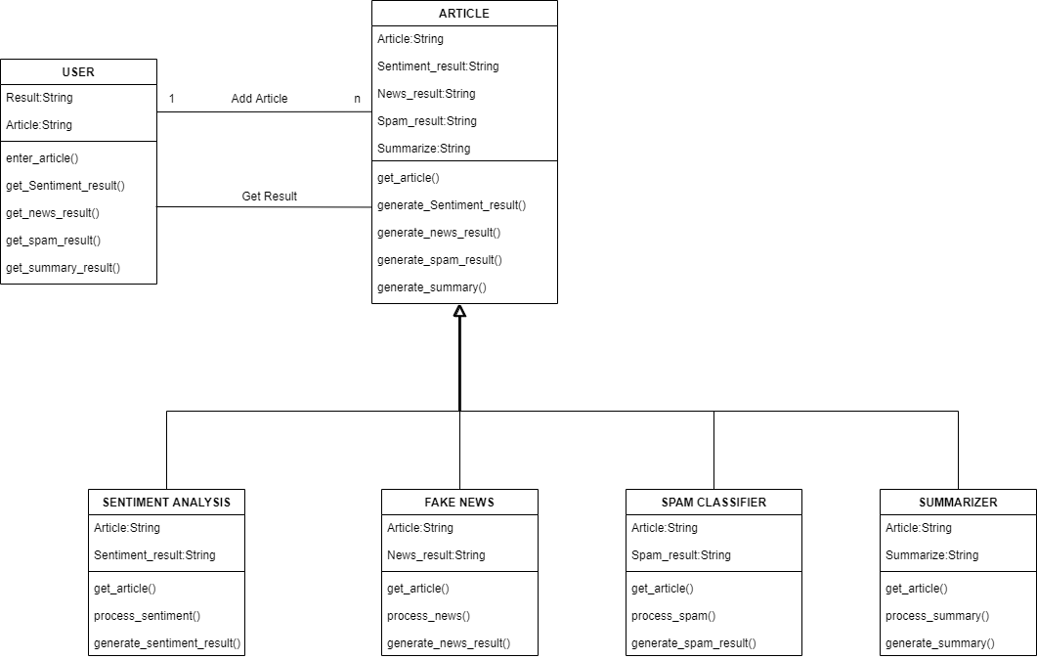

**Description for detailed class diagram**

1.Class user

There are following methods and attributes in class user

I Attributes-

a.Article-Contain the article to be validated, spam classified, summarized or sentiment identified

b.result-Stores any of the one result as only on result is generated at the time

II Methods-

a.enter_article() - Method allowing system to get article from user

b.get_sentiment_result() - Method allowing user to get result of sentiment analysis

c.get_news_result() - Method allowing user to get result of news analysis

e.get_spam_result() - Method allowing user to get result of spam analysis

f.get_summary_result() - Method allowing user to get result of summary of article

2 Article

I Attributes-

a.Article-Contain the article to be validated, spam classified, summarized or sentiment identified

b.Sentiment_result-String Containing sentiment analysis result.

c.News_result-String Containing Fake news result.

d.Spam_result-String Containing Spam analysis result

e.Summarize-String Containing Summary of Article

II Methods-

a.get_article() - Method allowing system to fetch article entered by user.

b.generate_sentiment_result() - Method allowing system to generate result using sentiment analysis

c.generate_news_result() - Method allowing system to generate result using Fake news analysis

e.generate_spam_result() - Method allowing system to generate result using spam analysis

f.generate_summary_result() - Method allowing system to generate summary of article

2.1 Sentiment Analysis

I Attributes-

a.Article-Contain the article to be validated, spam classified, summarized or sentiment identified

b.Sentiment_result-String Containing sentiment analysis result.

II Methods-

a.get_article() - Method allowing system to fetch articles entered by user.

b.process_sentiment()-Method allowing the system to extract type of sentiment from analysis of articles.

c.generate_sentiment_result() - Method allowing system to generate results using sentiment analysis.

2.2 News Analysis

I Attributes-

a.Article-Contain the article to be validated, spam classified, summarized or sentiment identified

b.News_result-String Containing Fake news analysis result.

II Methods-

a.get_article() - Method allowing system to fetch articles entered by user.

b.process_news()-Method allowing the system to extract type of news from analysis of articles.

c.generate_news_result() - Method allowing system to generate results using Fake news analysis.

2.3 Spam Analysis

I Attributes-

a.Article-Contain the article to be validated, spam classified, summarized or sentiment identified

b.Spam_result-String Containing Spam analysis result .

II Methods-

a.get_article() - Method allowing system to fetch articles entered by user.

b.process_article()-Method allowing the system to extract whether the article is spam or not from analysis of articles.

c.generate_spam_result() - Method allowing system to generate result using spam analysis

2.4 Summarizer

I Attributes-

a.Article-Contain the article to be validated, spam classified, summarized or sentiment identified

b.Summarize-String Containing Summary of Article

II Methods-

a.get_article() - Method allowing system to fetch articles entered by user.

b.process_article()-Method allowing the system to extract summary of article.

f.generate_summary_result() - Method allowing system to generate summary of article

**5.4 Detailed Object Diagram**

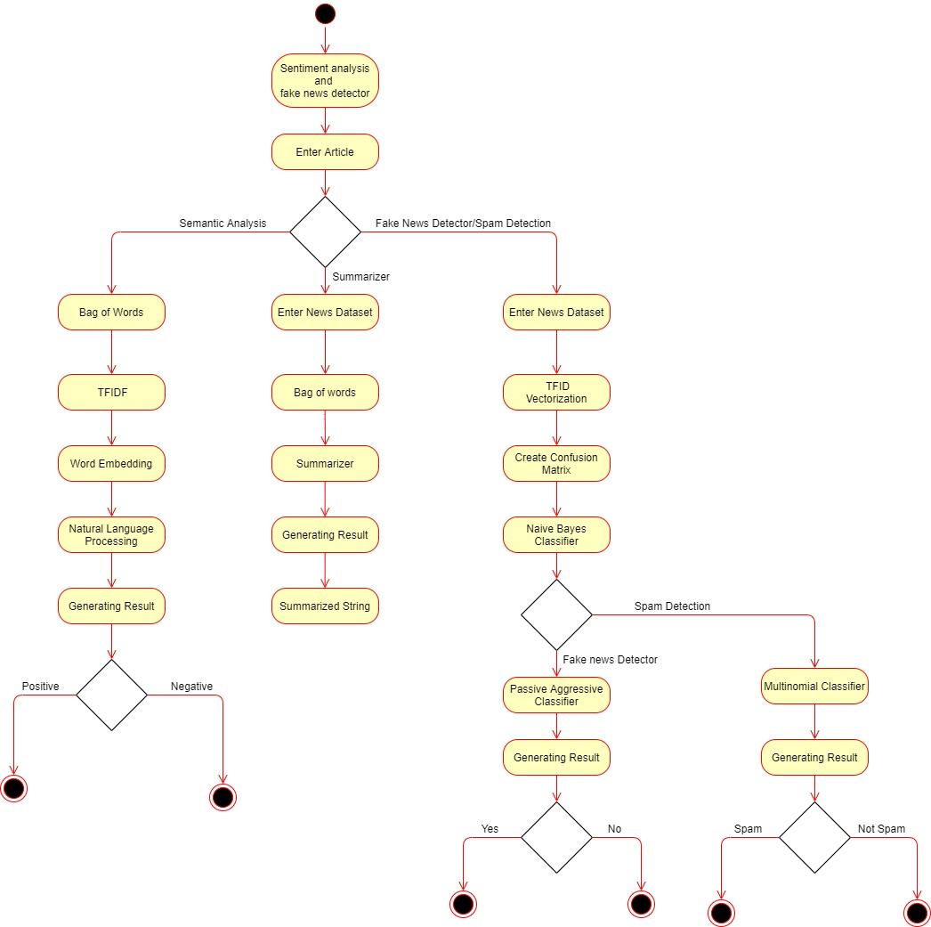

**Description for activity diagram**

1.The first activity is visiting the website.

2.The second activity is Enter Article Here users enter the news article.

3.In the third activity the user has to select the activity he wants to perform out of four activities listed as Sentiment Detection, Summarizer, Fake News Detector and Spam Detector.

4.If the User chooses the activity Sentiment Detection Then following are the next activities performed-

4.1.The first activity is creating a bag of words, it is a function in which a text (such as a sentence or a document) is represented as the bag (multiset) of its words, disregarding grammar and even word order but keeping multiplicity.

4.2.The Second activity is TFIDF VECTORIZATION here the frequency of each word is counted and stored.

4.3.The third activity id word embedding. Word embedding is any of a set of language modeling and feature learning techniques in natural language processing (NLP) where words or phrases from the vocabulary are mapped to vectors of real numbers.

4.4.Next step is applying Natural Language Processing to Extract the sentiment of the string.

4.5.The fifth activity is generating results out of the analysis.

4.6.If last step is positive means that sentiment is positive else sentiment is negative.

5.If the user chooses the activity summarizer the following activities are performed-

5.1.First activity is converting the article into the form of a dataset.

5.2.The Second activity is creating the bag of words. It is a function in which a text (such as a sentence or a document) is represented as the bag (multiset) of its words, disregarding grammar and even word order but keeping multiplicity.

5.3.The third activity is applying the summarize function.

5.4.The last activity is generating the results out of analysis.

6.If the person chooses activities Fake news detector or Spam detector following are the common activities involved in both-

6.1.The first activity in both activities is converting the article in the form of a dataframe that is a dataset.

6.2.The second activity is applying the TFIDF VECTORIZATION that is counting the frequency of each term in the article

6.3.The next activity is creating the confusion matrix for getting the accuracy matrix.

6.4.The next activity is applying the Naive bayes Classifier.

6.5.If the person has chosen Fake new detector here are some other activities involved-

6.5.1.The next activity is applying the passive aggressive classifier which remains passive the condition is true and becomes aggressive when the condition is false.

6.5.2.The next activity is generating the result from the analysis, if the condition is yes it means the news is true, else if condition is no it means the news is fake.

6.6.If the person have chosen Spam Detector here are some other activities involved-

6.6.1.The next activity is applying the multinomial classifier to get the desired result

6.6.2.The next activity is generating the result from the analysis, if the condition is yes it means the article is Spam, else if condition is no it means the article is not Spam.

**5.5 Object Diagram**

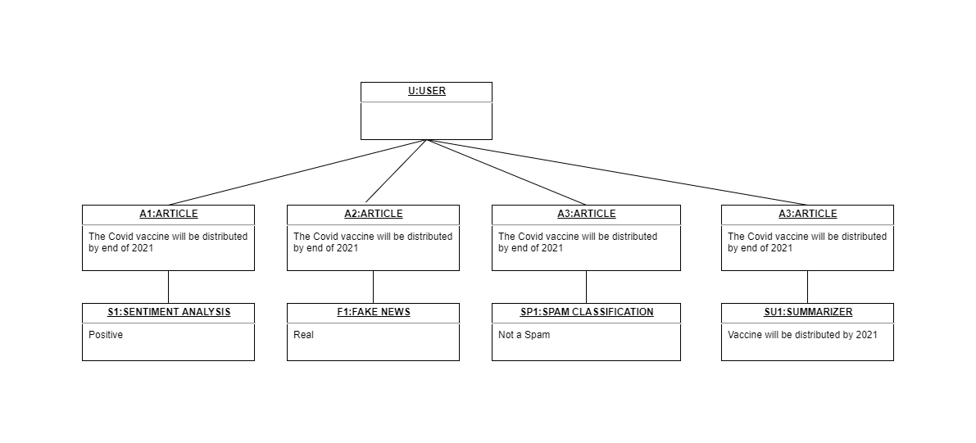

Description

In object diagram is a graph of instances, including objects and data values. A static object diagram is an instance of class diagram that shows the snapshot of the detailed state of the system at a point in time. The use of object diagrams is fairly limited, namely to show examples of data structure.

In the object diagram there are two objects- user and Article. These objects are connected through a single association. User and system object have one same attribute article-Which is the article to be validated and the system also contains one more attribute output.

The Article class is generalized into four sub classes namely which are used one at a time:

* Fake News Detector-It Detects Whether the article is true or false.
* Sentiment Detector-It shows the sentiment of the particular article(Positive/Negative).
* Spam Detector-Detects Whether the article is spam or not.
* Summarizer-Provides the summary of the article

**5.2 INTERACTION DIAGRAM**

**5.2.1 SEQUENCE DIAGRAM**

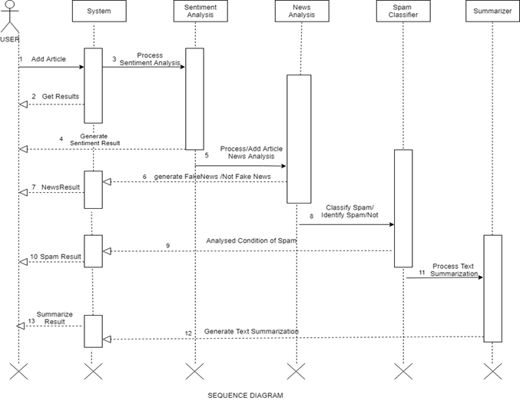

**Description-**

1.The initialization of process takes place.

2.The system object is called which in turn initiates other objects.

3.In case of Sentiment analysis the system takes the article and passes it to another object called Sentiment analysis which generates an analysis report from which the system generates a result and passes it to the user. The result specifies the sentiment(positive or negative) of the article.

4.In case of Fake News analysis the system takes the article and passes it to another object called Fake News analysis which generates an analysis report from which the system generates a result and passes it to the user. The result specifies the validity(true or false) of the article.

5.In case of Spam analysis the system takes the article and passes it to another object called Spam analysis which generates an analysis report from which the system generates a result and passes it to the user. The result specifies the authenticity(spam or not spam) of the article.

6.In case of Summarizer the system takes the article and passes it to another object called Summarizer which generates an analysis report from which the system generates a result and passes it to the user. The end result is the summary of the article.

7.At last there is End of the process which is the termination of project.

**5.2.2 Collaboration Diagram**

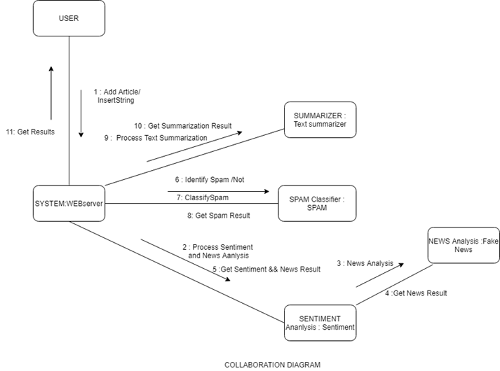

**Description-**

1.The initialization of process takes place.

2.The System WEBserver object is called for getting articles from the user for performing different operations.

3.After System WEBserver is called there are three different objects that can be called followed as Sentiment Analysis, Spam Classifier, Summarizer.

4.There is one more object that is called after selecting the Sentiment Analysis that is the Fake News Analysis object.

5.The Summarization object is called to get the process text summarization of the article and the object generates a summary as the result.

6.After Summarization the system generates the summary which is transferred to the user.

7.The Spam Analysis object is called for identifying whether the given article is spam or not.

8.After Spam Analysis the system generates the result which is transferred to the user.

9.The sentiment Analysis object is called with the objective of abstracting sentiment(positive or negative) from the article.

10.After Sentiment Analysis the system generates the result which is transferred to the user or the Fake News Analysis object is called.

11.After sentiment analysis if Fake News Analysis object is called then it is called with the aim of identifying whether the article is fake or not.

12.After Fake News Analysis the system generates the result which is transferred to the user.

12.At last there is End of the process which is the termination of the project.

**5.3 State Diagram**

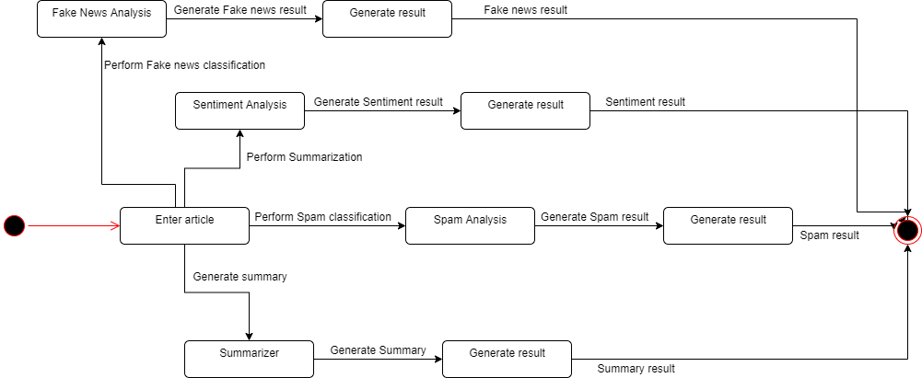

**Description-**

1.The first state of the user is to enter an article.

2.There are multiple states after the first state.

2.1.One of the following states is fake news analysis.

2.1.1.The next state is generating result of the analysis

2.2.Onother of the following states is sentiment analysis.

2.2.1.The next state is generating result of the analysis

2.3.Onother of the following states is spam detection.

2.3.1.The next state is generating result of the analysis

2.4.Last of the following states is summarization of articles.

2.4.1.The next state is generating result of the analysis

**5.6Component Diagram**

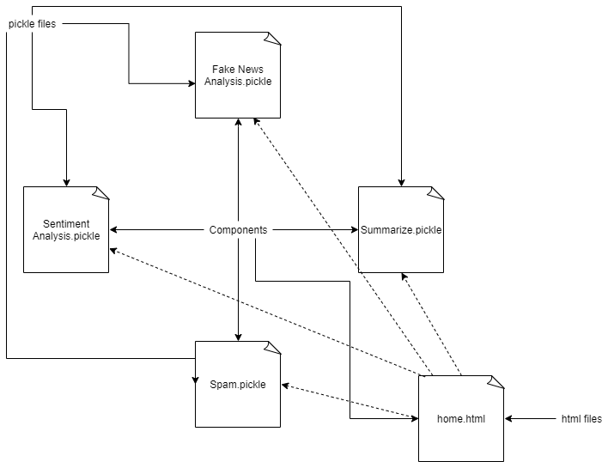

**Description-**

1.There are two types of files first is pickle and another is html

2.There are total 4 pickle files-

2.1.The first is fake news analysis which is used to predict whether the result is true or not.

2.2.Next is Sentiment Analysis which is used to get sentiment of the result

2.3.Next is spam analysis which is used to predict whether the news is spam or not

2.4.The last file is summarize which is used to get the summary of the article.

3.The next type of file is html file which provide the home page and base pages form all pickle files.

**Deployment Diagram**

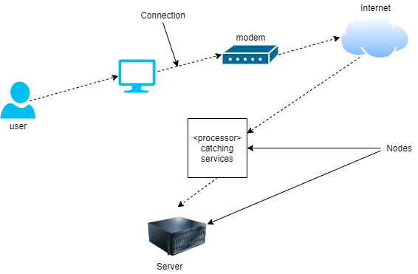

**Description-**

1.The user uses a device such as computers to get connected to the internet.

2.The internet is provided using modem by service provider.

3.The internet sends user requests to the server.

4.The server processes the user request to provide the correct solution.

5.The server then responds back with the solution to the request.

**5.7 TEST PLANS AND IMPLEMENTATION IMAGES**

**Test Plan**

A **Test Plan** is a detailed document that describes the test strategy, objectives, schedule, estimation, deliverables, and resources required to perform testing for a software product. Test Plan helps us determine the effort needed to validate the quality of the application under test. The test plan serves as a blueprint to conduct software testing activities as a defined process, which is minutely monitored and controlled by the test manager.

As per ISTQB definition: “Test Plan is A document describing the scope, approach, resources, and schedule of intended test

Making Test Plan document has multiple benefits -

* Help people outside the test team such as developers, business managers, customers **understand**the details of testing.
* Test Plan **guides** our thinking. It is like a rule book, which needs to be followed.
* Important aspects like test estimation, test scope,[Test Strategy](https://www.guru99.com/how-to-create-test-strategy-document.html)are **documented** in Test Plan, so it can be reviewed by Management Team and re-used for other projects.

|  |  |  |
| --- | --- | --- |
| **S. No.** | **Parameter** | **Description** |
| 1. | Introduction | Fake news detection and sentiment analysis is a web-based application that predicts the information or news is fake or genuine and also analyze the sentiment of information is positive, negative or neutral and also help in finding spam classification and summary of the information. |
| 2. | Features to be tested | The feature that needs to be tested are fake news detection and sentiment Analysis of information or news. |
| 3. | Test schedule | It includes some variety of the phases. For ex. Requirement understanding, test plan creation, test cases, test execution in different environments.   * Firstly, team understands the requirements for implementation of the projects. * Then create the schedule for every phase or functionality. * Then test every functionality of system that means buttons in application, output result or recommendation and then make test cases for the test results. * After the test cases system will check on every platform or device for the environment testing. * If all testing will complete successfully then system will ready for run and then we stop testing. |
| 4. | Environmental testing | We need some environmental requirements such as hardware, software, OS, network configurations, tools required that are system should have at least 4gb RAM, 500gb hard disk, windows 7,8,10 and 2mbps network connection. |
| 5. | Open risk/issue | In implementation we face some issues that are data accuracy, calculations. Some functionality which are left to implement and testing. System have also some bugs and error which we will resolve soon. |
| 6. | Exit criteria | When system has no bug/error and all functionality work properly and also system run on every platform then we will stop testing and system will ready for run. |

Test Cases –

A **TEST CASE** is a set of actions executed to verify a particular feature or functionality of your software application. A Test Case contains test steps, test data, precondition, postcondition developed for specific test scenario to verify any requirement. The test case includes specific variables or conditions, using which a testing engineer can compare expected and actual results to

determine whether a software product is functioning as per the requirements of the customer.

|  |  |  |  |  |  |  |  |
| --- | --- | --- | --- | --- | --- | --- | --- |
| **S.No.** | **Title** | **Input** | **Action** | **Expected Output** | **Actual Output** | **Status** | **Remark** |
| 1. | Verify whether application launched on local system or not. | Enter run commands | Open application on the local system. | Application should run on local system browser. | Application successfully run on local system | Pass |  |
| 2. | Verify that the application’s display is adapted to the screen and all the buttons and menus work properly. |  | Open application in browser and check screen size and buttons. | Application display should adaptable in screen size and all buttons and menu work properly. | Application display is adaptable in screen size and all buttons and menu work properly. | Pass |  |
| 3. | Verify user able to enter information or news. | Click on text area. | Enter some information or news link. | Application allows to enter the information or news. | Application allow to enter the information or news successfully. | Pass |  |
| 4. | Check application able to process or show result on the screen. | Click on proceed. | Enter some information or news link and proceed further. | Application shows the result on the screen. | Application shows the result on the screen successfully. | Pass |  |
| 4. | Check application able to process or show result on the screen. | Click on proceed. | Enter some information or news link and proceed further. | Application shows the result on the screen. | Application shows the result on the screen successfully. | Pass |  |
| 5. | Check application provides result that news or information is fake or genuine. | Click on proceed. | Enter some information or news link and proceed further. | Application shows the result that information or news is fake or genuine. | Application provides the result that information or news is fake or genuine successfully. | Pass |  |
| 6. | Check application provides result which shows sentiment of the news or information i.e. positive, negative or neutral. | Click on proceed. | Enter some information or news link and proceed further. | Application shows the result that information or news is either positive, negative and neutral. | Application provides the result that information or news is either positive, negative and neutral successfully. | Pass |  |